**Project on**

**Medical Data Visualizer**

**A training report**

Submitted in partial fulfillment of the requirements for the award of degree of

**Master in Computer Applications**

**Submitted to**

**LOVELY PROFESSIONAL UNIVERSITY**

**PHAGWARA, PUNJAB**



**From MM/DD/YY to MM/DD/YY**

**SUBMITTED BY**

**Name of student:** Aniket Kumar

**Registration Number:** 12108348

**Signature of the student:**

**CONTENTS**

|  |  |  |
| --- | --- | --- |
| **S.No.** | **Title** | **Page** |
| 1 | Declaration by Student |  |
| 2 | Training Certification from organisation |  |
| 3 | Acknowledgement |  |
| 4 | List of Tables |  |
| 5 | List of Figures/Charts |  |
| 6 | Introduction of the Project Undertaken |  |
| 7 | Brief description of the work done |  |
| 8 | Code Snippets |  |
| 9 | Outcome of the Project |  |
| 10 | Conclusion |  |
| 11 | References |  |

**To whom so ever it may concern**

I, **Aniket Kumar**, **12108348**, hereby declare that the work done by me on “**Medical Data Visualizer**” from **June, 2022** to **July, 2022**, is a record of original work for the partial fulfillment of the requirements for the award of the degree, **Master in Computer Applications**.

Aniket Kumar (12108348)

Signature of the student

Dated:

**CERTIFICATE**

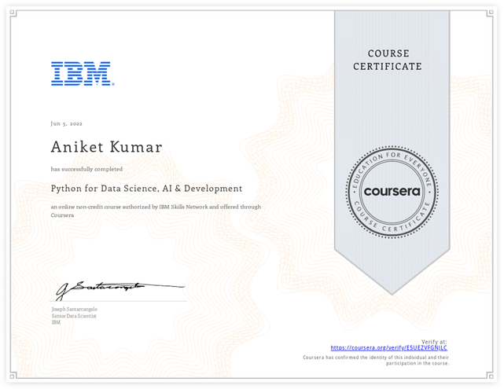

**ACKNOWLEDGEMENT**

**LIST OF TABLES**

**LIST OF FIGURES/CHARTS**

**INTRODUCTION OF THE PROJECT UNDERTAKEN**

Objectives of the work undertaken

Scope of the Work

Importance and Applicability

Role and profile

**Brief description of the work done**

Position of Internship and roles

Activities/ equipment handled

Challenges faced and how those were tackled

Learning outcomes

Data analysis

**CODE SNIPPETS**

**OUTCOME OF THE PROJECT**

**CONCLUSION**

**REFERENCES**